SFOAC EXECUTIVE MEETING
Monday September 28, 2020
The Cloud @ 7:00pm
1.0 Call to Order at 7:10pm
1.1 Roll Call
Question: If you had to choose one app to keep on your phone which one would it be?
1.2 Adoption of the Agenda
Josh M motions to adopt the agenda, Kyle seconds the motion
1.3 Approval of the Minutes
Kyle motions to approve the minutes, Josh W seconds the motion

2.0 Chairperson Remarks – Emma Richards
2.1 - Oath of Office for Kevin – will do so next week
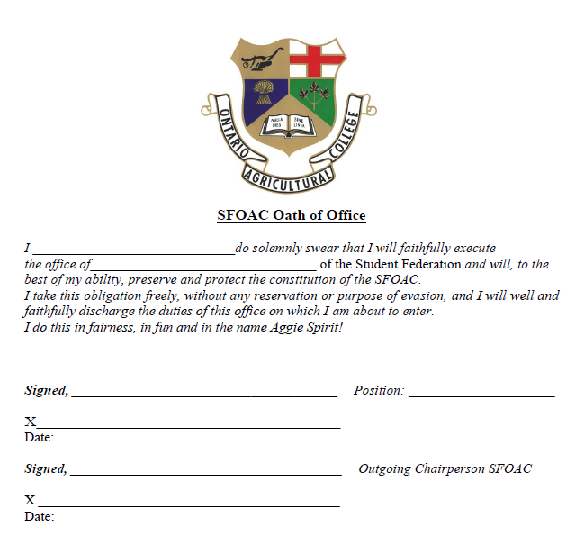
2.2 - 2024’s meeting Wednesday Sept 30 @ 7pm via Teams
2.2.1 - Polling will occur via Qualtrics

3.0 Executive Reports
3.1 President – Josh Moran
3.1.1 - Sean Mitchell Vice President Academic
3.1.1.1 - Encourage your respective classmates to go out and vote, link in email inbox
3.1.2 - Clothing Orders, first year leathers especially
3.1.2.1 - Put up a sizing chart & include photos of current students
3.1.2.2 - Hudson & Emma to help
3.2 VP External – Kyle Farquharson
3.2.1 - Resume Night – Mike Bachner is unable to do an online presentation
3.2.1.1 - Look into another speaker from a co-op or from the Ag Bus Dept.
3.2.2 - Careers and Cocktails – Alumni is hosting October 5, 2020 @ 8:15
3.2.2.1 - Please share with classmates, Facebook event coming
3.2.3 - Virtual Job Fair – Via Symplicity October 6, 2020 @ 10-3
3.2.3.1 - SFOAC will have a virtual booth, watch for sign-ups to staff the booth

3.2.4 - Food Drive September 30th - October 9th
3.2.3.1 - Encourage monetary donations amongst your class & program
3.3 VP Internal – Josh Weber
3.3.1 - Pub Themes – Every class and program executive must submit a theme
3.3.2 - Accreditation – completed, organizations can now be re-accredited
3.2.2.1 - Submit completed accreditations to Josh via email

4.0 Committee Reports
4.1 SRM/BSc.Agr. – Riley Bauman
4.1.1 ALL online events must be submitted for SERM - this includes club meetings and executive meetings (alcohol or not)
4.1.1.2 - If they are regular meetings you can accredit all at once
4.1.2 Reminder email for accreditation
4.2 CSA Rep – Kendra Cornelissen
4.2.1 - Nothing to report

5.0 Communications Reports
5.1 Secretary Report – Hannah Symington
5.1.1 - Nothing to report
5.2 Public Relations Report – Maggie-Jo Hickson
5.2.1 - Storefront on Aggies.ca Website
5.2.1.1 - Two free plug ins that could be used, shipping will be difficult, many fees associated, leave it to the side for now but upload images to the website
5.2.1.2 - Look to Dean’s Office and/or Student Executive Council for options on distributing clothing
5.2.2 - Meeting Minutes
5.2.2.1 - Executive minutes only to go on website

6.0 Program and Class Reports
6.1 Turfgrass Management – Kevin Alder
6.1.1 - Still trying to find location to host Turf Club

6.2 Graduate Student – Olivia Noorenberghe
6.2.1 - GSC Looking into hosting OAC Graduate Virtual Career Event with Panelists from different OAC sectors
6.2.2 - Looking into OAC Grad Student Swag
6.2.3 - Next meeting Oct 6
6.3 LASS – Nicole Litwin
6.3.1 - Not in attendance
6.4 B.Commerce – Ian Burtwistle
6.4.1 - Nothing to report
6.5 BBRM – Pamela Terreberry
6.5.1 - Student council meeting this Thursday
6.5.2 - Clothes will be out of the lounge this Tuesday
6.6 Food Science – Erika Rupar
6.6.1 - First virtual Food Science Meeting last week
6.7 Animal Biology – Talia Dee
6.7.1 - Nothing to report
6.8 Environmental Science – Victoria Snyder
6.8.1 - ESSE elections nomination period happening now until October 4th
6.8.2 - Thank you Hannah for helping us out with a new newsletter
6.8.3 - Looking to do more virtual events especially for first years
6.8.4 - Discussing merchandise at this week’s meeting
6.9 OAC 2021 - Janelle Gras
6.9.1 - Nothing to report
6.10 OAC 2022 – Hudson Bell
6.10.1 - Nothing to report
6.11 OAC 2023 – Faith Emiry
6.11.1 - Information Technology Meeting - discussed cybersecurity
6.11.1.1 - Awareness roadshow going virtual this year featuring a virtual scape room, event coming soon
6.12 OAC 2024 – Vacant

7.0 Financial Report – Patrick McCarthy
7.1 - Reimbursement form has been posted
7.2 - Budget Approval
7.2.1 - Hannah motions to approve the budget, Emma seconds the motion. Motion carried
8.0 Other New Business

9.0 Adjournment
9.1 - Emma motions to adjourn the meeting at 8:13pm, Josh M seconds the motion.

