SFOAC EXECUTIVE MEETING
Monday March 29th, 2021
The Cloud @ 7:00pm
1.0 Call to Order
1.1 Roll Call
Meeting called to order at 7:02pm
Question: Are you incoming or outgoing Exec and what is your position?
1.2 Adoption of the Agenda
Patrick motions to adopt the agenda, Josh M seconds the motion.
1.3 Approval of the Minutes
Amendment: Josh W to be reimbursed in the amount of $350 for gift cards, not $225. Hannah motions to approve the minutes with the aforementioned amendment, Kyle seconds the motion.
2.0 Chairperson Remarks – Emma Richards
2.1 - Welcome to our new 2021-2022 SFOAC Executive
3.0 Executive Reports
3.1 President – Josh Moran
3.1.1 - STEF Funding Completed (See appendix)
3.2 VP External – Kyle Farquharson
3.2.1 - Reminder to class reps to share that 2020 Pigroast cups are available for $5. Email vpexternal@aggies.ca if interested.
3.3 VP Internal – Josh Weber
3.3.1 – Reimbursement in the amount of $350 for prize gift cards
3.3.2 - Get your recs in, DO NOT leave Guelph without submitting them
4.0 Committee Reports
4.1 SRM/BSc.Agr. – Riley Bauman
4.1 - Nothing to report
4.2 CSA Rep – Kendra Cornelissen
4.2.1 - Not in attendance

5.0 Communications Reports
5.1 Secretary Report – Hannah Symington
5.1.1 - Nothing to report
5.2 Public Relations Report – Maggie-Jo Hickson
5.2.1 - UoG FoodTalk Team Applications due April 16th, see class Facebook pages for more info
6.0 Program and Class Reports
6.1 Turfgrass Management – Kevin Alder
6.1.1 - Not in attendance

6.2 Graduate Student – Olivia Noorenberghe
6.2.1 - Nothing to report

6.3 LASS – Nicole Litwin
6.3.1 - Nothing to report

6.4 B.Commerce – Ian Burtwistle
6.4.1 - Not in attendance
6.5 BBRM – Pamela Terreberry
6.5.1 - BBRM Student Council elections
6.6 Food Science – Erika Rupar
6.6.1 - Spill the Beans networking event was a great success
6.7 Animal Biology – Talia Dee
6.7.1 - ABSA executive turnover meeting tonight
6.8 Environmental Science – Victoria Snyder
6.8.1 - Nothing to report
6.9 OAC 2021 - Janelle Gras
6.9.1 - Nothing to report
6.10 OAC 2022 – Hudson Bell
6.10.1 - Outgoing Class meeting April 12th @ 7pm
6.11.1 - Class beard challenge ongoing
6.11 OAC 2023 – Faith Emiry
6.11.1 - Not in attendance

6.12 OAC 2024 – Karen Reymer
6.12.1 - Nothing to report
7.0 Financial Report – Patrick McCarthy
7.1 – Patrick motions to approve the payment of $197.75 to Kyle Maw for the maintenance and renewal of the aggies.ca domain. Motion seconded by Josh M. All in favour. Motion carried.
7.2 - Message Patrick as soon as possible if you have any outstanding expenses requiring reimbursements
7.3 - If you are a part of a club, class or program please ensure any SFOAC cheques are cashed as soon as possible.
8.0 Other New Business
8.1 Oath of Office for new members
8.2 - Important thanks from Josh M
9.0 Adjournment
Motion to adjourn the meeting at 7:20pm. Erika seconds the motion.
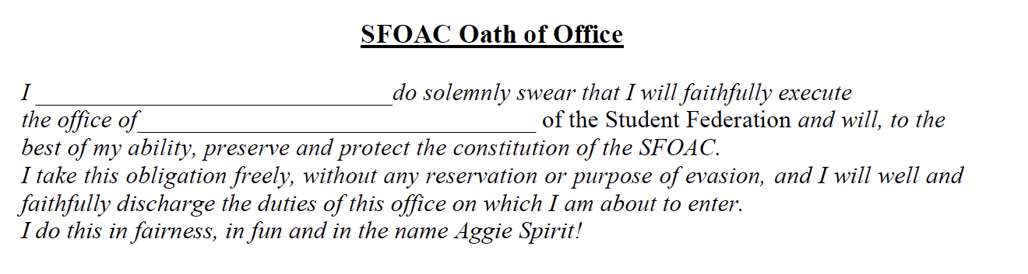

Appendix 1
STEF Meeting
Present: Joshua Moran, Joshua Weber, Patrick MacCarthy, Ian Burtwistle, Riley Bauman, Erika Rupar, Victoria Snyder, Nicole Litwin, Natalia Dee, Pamela Terreberry
Absent: Kyle Farquharson, Kevin Alder, Emma Richards
Meeting called to order, 6:30
Dean's Office Proposal
Request - $18,000 - $108,000
Motion to fund the Dean's Office's proposal in the amount of $18,000.
Motioned by Josh Moran, Seconded by Erika Rupar
Comments – Concern stemmed from students regarding being unable to obtain a final budget for the project. Some members voiced concern regarding the pricing of technology being added to these rooms. However, members ultimately concluded that it is critical to have a firm plan for the gradual and safe return to campus with the uncertainty of transitioning into the upcoming Fall semester. We hope that the funding assists in advancing the student learning environment and positively impacting OAC students.
For – 10
Against – 0
Abstaining – 0
Motion Carried
SEDRD Proposal
Request - $23,513.04
Motion to fund the SEDRD's proposal in the amount of $23,221.95.
Motioned by Josh Moran, Seconded by Erika Rupar
Comments – Members of SFOAC's STEF committee were very impressed by SEDRD's application. The growing BLA program now ranking as the 3rd largest in the world is an impressive feat that emphasizes this funding's impact. As a highly hands-on program, we recognize the importance of the technology being used within the academic unit. Unfortunately, due to constraints this year, we are unable to fund the total amount requested due to other considerations; however, we want to support the academic unit with funding to the amount of $23,221.95.
For – 10
Against – 0
Abstaining – 0
Motion Carried
SES Proposal
Request - $24,428.59
Motion to fund the SES proposal in the amount of $24,118.
Motioned by Josh Moran, Seconded by Erika Rupar
Comments – SFOAC's STEF committee was very impressed by the proposal submitted by SES. The introduction of a new program to further enrich the OAC's learning environment is of great value. We are delighted to see SES tangibly contributing to that. We were very impressed by the number of students each component of the proposal would be able to reach. The proposal was very strong; however, due to constraints this year, we are unable to fund the total amount requested due to other considerations. However, we want to support the academic unit with funding for $24,118. We hope that the funding goes a long way in assisting in fulfilling the proposed items.
For – 10
Against – 0
Abstaining – 0
Motion Carried
FARE Proposal
Request - $10,120
Motion to fund FARE's Proposal in the amount of $10,120.
Motioned by Josh Moran, Seconded by Erika Rupar
Comments – SFOAC's STEF committee was impressed by FARE's proposal. Given the quality of the Futures and Options course and the value of the trading simulation emphasized by members of the committee, and the well put together budget regarding the improvements of room 319 in the J.D. MacLachlan building, the STEF committee wishes to fund the proposal to the total amount.
For – 10
Against – 0
Abstaining – 0
Motion Carried
BBRM Proposal
Request - $30,000
Motion to fund BBRM's Proposal in the amount of $29,606.
Motioned by Josh Moran, Seconded by Erika Rupar
Comments - SFOAC's STEF committee was impressed by BBRM's proposal. This project's number of possible student interactions is exceptional, and the academic and hands-on benefits are extensive. Unfortunately, due to constraints this year, we are unable to fully fund the requested amount. However, we hope that $29,606 can go a long way in making this proposal come to fruition.
For – 10
Against – 0
Abstaining – 0
Motion Carried
Food Science Proposal
Request - $23,226.31
Motion to fund Food Science's proposal in the amount of $22,934.05.
Motioned by Josh Moran, Seconded by Erika Rupar
Comments - SFOAC's STEF committee was impressed by Food Science's proposal. Given the number of programs and the research quality that can amount to the purchase of the proposed technology, we find it extremely important to assist in funding the requested items. Unfortunately, due to constraints this year, we are unable to fully fund the requested amount. However, we hope that $23,226.31 can assist in the purchase of the equipment.
For – 10
Against – 0
Abstaining – 0
Motion Carried

Meeting adjourned at 6:59PM

